60th Anniversary and Africa Exhibition
30 November – 14 December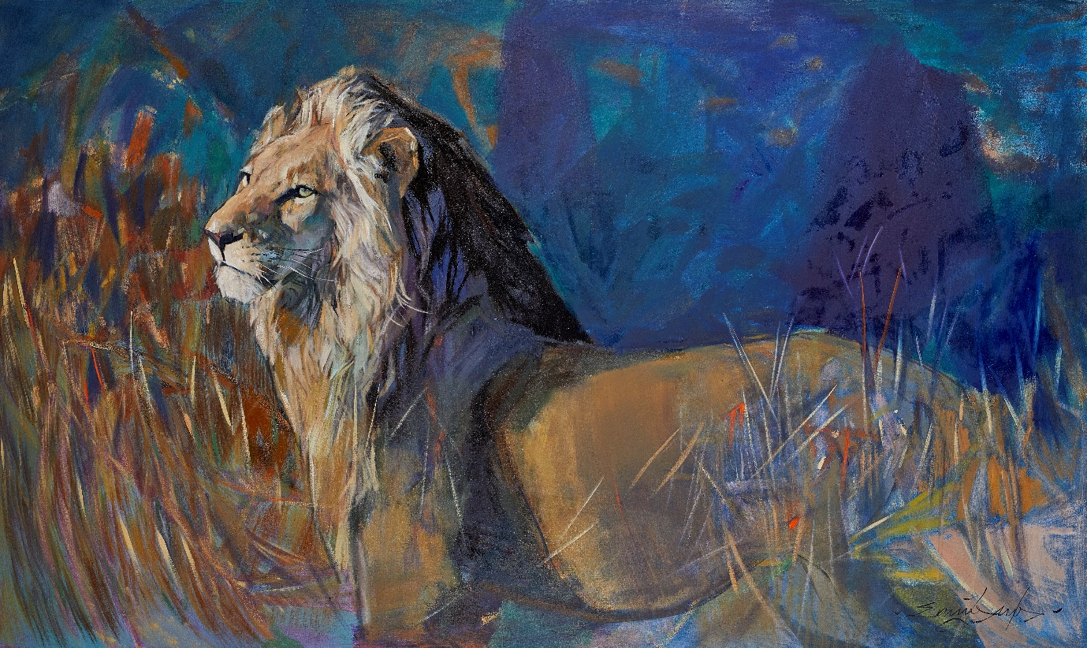
EMILY LAMB – Sunlit Lion
This year in conjunction with celebrating our 60th anniversary as specialist art dealers, we are holding our AFRICA show in collaboration with the David Shepherd Wildlife Foundation. The DSWF is an effective wildlife conservation charity funding key projects in Africa and Asia working to save endangered wildlife, they will be giving a talk at our AFRICA Preview to highlight their important work. A percentage of the sales from the show will be donated to support the ongoing work of the DSWF.
Highlights of the show include paintings by David Shepherd, Mandy Shepherd, Emily Lamb, Paul Augustinus, Keith Joubert, Wilhelm Kuhnert and others, as well as sculptures by Pascal Chesneau and Camilla Le May.
In order to show the larger works to full effect, we will be holding a 4 day preview of the show in a fabulous contemporary barn, at Parsonage Farm, Kirdford, a few miles from our Petworth Gallery – courtesy of the generous Thomas family.
There will be a talk by the DSWF, a drinks reception and a chance to meet some of the artists involved. For further information please contact info@rountreetryon.com

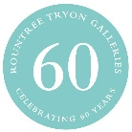
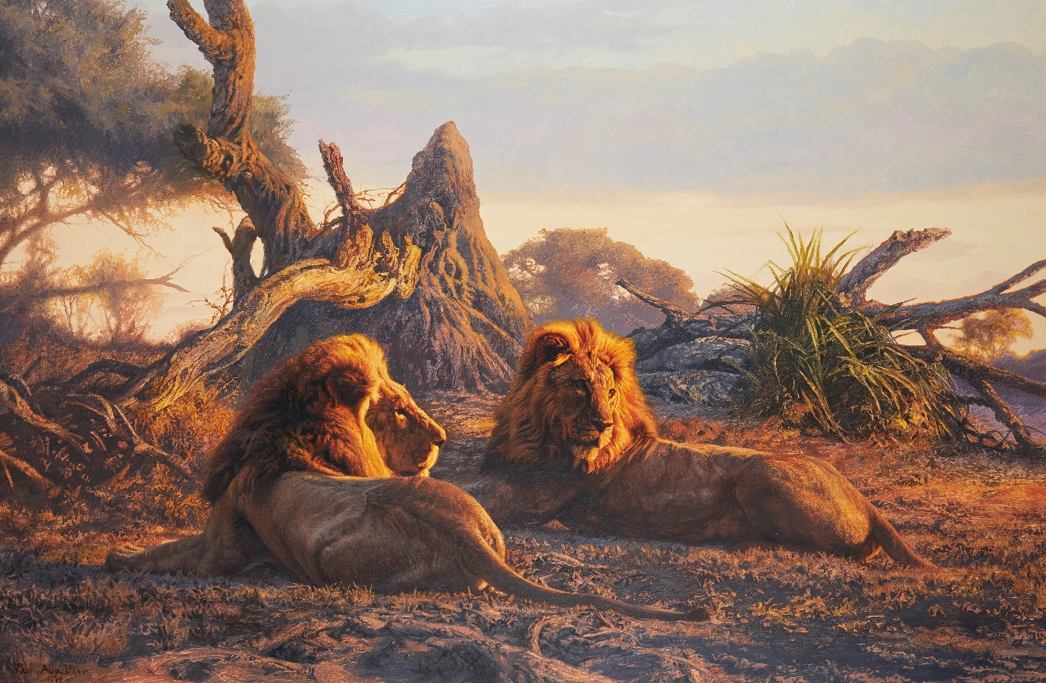
PAUL AUGUSTINUS - Lions
Viewing times and dates:

Parsonage Farm Barn, Kirdford, West Sussex, RH14 0NH
30 November – 4 December

- Preview day - Saturday 30th November 11am-8pm
- Viewing – Sunday 1st December – 11am-4pm
- Viewing – Monday 2nd December – 10am-5pm
- Viewing – Tuesday 3rd December – 10am-5pm
- Viewing - Wednesday 4th December – 10am-12 o’clock

Petworth Gallery, Market Square, Petworth, GU28 0AH
5 – 14 December

- Viewing – Monday-Friday - 10am-6pm
- Viewing – Saturday 7 December – 11am-7pm
- Viewing – Saturday 14 December – 11am – 4pm

